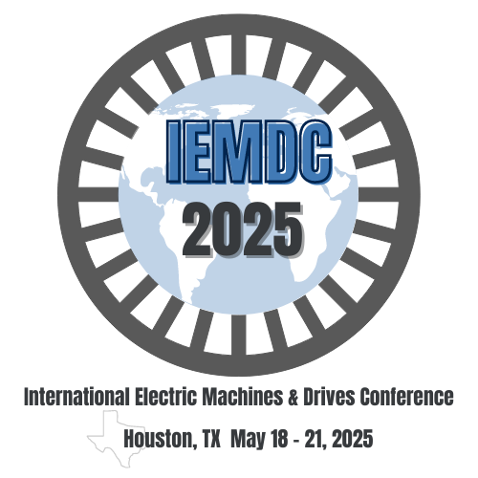
International Electric Machines and Drives Conference (IEMDC)
Student Project Demonstration

Important Dates:
Jan 15, 2025
Deadline for submission of application form
Feb 15, 2025
Notification of acceptance or rejection
May 19, 2025
Demo date

Student project demonstrations on emerging technology award program.
The IEEE International Electric Machines and Drives Conference (IEMDC) is excited to announce the inaugural Student Project Demonstrations on Emerging Technology Award Program. This initiative, hosted by the IEEE IEMDC Committee on Student Activities, aims to inspire the next generation of researchers and innovators. Students will have the opportunity to present their cutting-edge projects and research findings, fostering interaction between academia and industry leaders. Participants will showcase their work in electric machines and drive systems, highlighting the capabilities and potential of emerging technologies. Three award certificates will be granted to the best student demonstrations, encouraging excellence and innovation. This event will also serve as a platform for networking and collaboration, connecting students from diverse universities and countries. We look forward to your participation in this exciting new venture at IEMDC 2025!

Submission Guidelines and Award Details
To participate in the student project demonstrations on emerging technology award program, submit the online form by Jan 15, 2025. If you have difficulty accessing this form, please email calebli@ieee.org with your name, school, and faculty advisor’s name & email.
Single student project teams will be given preference, but teams with up to three students are allowed. For teams with multiple students, only one student needs to fill out the application form.
Topics of interest include all emerging areas of electrical machines and motor drives. A non-exhaustive list of topic areas of interest is given below. Project teams selected for participation will be notified by Feb 15, 2025. All members of the selected project teams must register for IEMDC in order to participate in the demonstration event.
For the demonstration, each team will be provided (free of cost) roughly 5-feet by 10-feet space in the IEMDC exhibition hall as well as one standing easel (board/poster not included). It is recommended that teams demonstrate hardware prototypes, and utilize posters, slides and/or videos (recorded at their home institution) to explain their demo to the audience and the judges. A 120V power outlet will be available to each team to run a computer. However, the demonstrated hardware and experiments cannot be run in the exhibition hall due to safety concerns. Any participant who violates this rule will be disqualified.
Each project demonstration will be evaluated by a judging panel comprising members from the industry and the academia. The panel members will select the top project demonstrations based on originality/creativity, engineering design, value to practical applications, presentation, and audience appeal. The top three student project teams will be recognized with the Student Project Demonstration on Emerging Technology Award Certificates:
- Best innovative idea
- Best demo presentation
- Best design methodology

Topics of Interest | THESE ARE 2025 TOPICS
Topics of interest include but are not limited to:
- Advanced Electric Motor Designs
- High-Efficiency Motor Drives
- Motor Control Techniques
- Integration of Electric Machines with Renewable Energy
- Artificial Intelligence in Motor Control
- Emerging power devices (e.g., SiC, GaN) and their applications in Motor Drives
- Electromagnetic Compatibility (EMC) in Electric Drives
- Emerging solutions for passive component used in motor drives
- High reliable power electronic components used in motor drives
- Design automation and real-time simulation tools for machines and drives
- Smart Motor Systems and IoT Integration
- Advanced Cooling Techniques for Electric Machines
- Digital twin and cyber-physical security of motor drives
- Other emerging technologies for machines and drives

